Lindsay Sheppard

Sociology 555: Community and Social Change

A Comprehensive Plan for Clay County, Florida

**Overview**

According to Chandler (2000), many counties implement what is called a “comprehensive plan”, particularly when growth is occurring or expected to occur in the near future. Comprehensive planning provides a guide for expected future growth, development, and change. Such plans require preparation steps, such as planning to plan, gathering and analyzing data, identifying problems and concerns, and setting goals and objectives (Chandler, 2000).

Implementation of these steps for Clay County, Florida provided insight and suggestions to the county for future growth. Clay County (Figure 1) is located in the southwestern portion of the Jacksonville, Florida metropolitan statistical area (MSA). The county is home to the small cities of Green Cove Springs and Keystone Heights, the towns of Middleburg and Orange Park, and many unincorporated areas, such as Fleming Island, Oakleaf Plantation, and Lake Asbury. Long considered a bedroom community, it is comprised of both suburban areas in the northeast and rural areas in the remainder of the county and was almost entirely rural until the 1970s, when the completion of a bridge improved Clay’s access to Duval County (Jacksonville) (Clay County, 2019). Clay is expected to become the fastest growing county in Florida by the end of the year 2019, mostly due to the expansion of the First Coast Expressway (SR 23) through the middle and eastern portion of the county and more than 10,000 homes that are being built in areas near to the expressway’s path (Rousseau, 2019). This expressway is expected to bring many jobs to Clay County, especially in Green Cove Springs (Sailer, 2019).

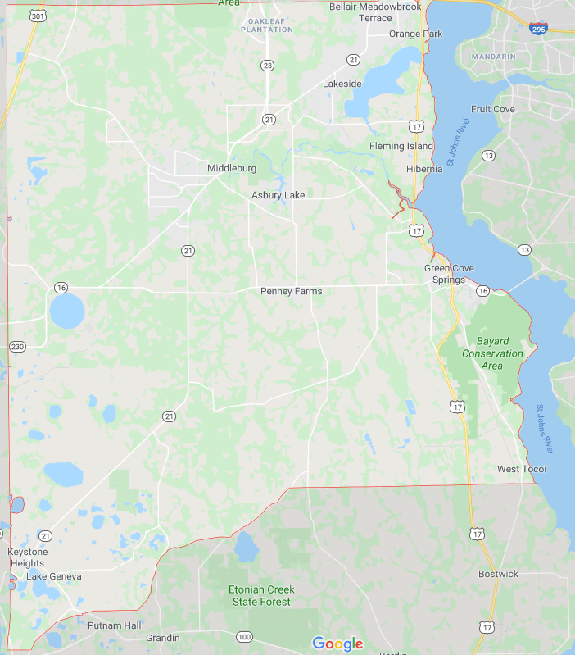

**Figure 1:** Map of Clay County, Florida

As of 2010 (U.S. Census Bureau), the population was approximately 190,865, with a racial distribution of 81.8% White, 9.9% Black, 7.7% Hispanic and Latino (of any race), 2.9% Asian, and 2.9% Two or More Races. As of 2017, the Census Bureau estimates suggest Clay County is growing, with a population of approximately 212,230, but otherwise very little change in racial demographics. While the county does provide almost 92,000 jobs for its residents, the majority of residents rely on neighboring counties such as Duval and St. John’s for work. Approximately 99.3% of county residents live in households. Over three-quarters of those are families and the same percentage own their own homes. The median household income of $61,971 is higher than the national ($59,039); the poverty rate of 10.4% is lower than the national rate (12.3%) (U.S. Census Bureau, 2017). Selected general characteristics from the 2010 U.S. Census Bureau for Clay County can be viewed in Table 1.

**Table 1: General characteristics for Clay County, Florida (U.S. Census Bureau, 2010).**

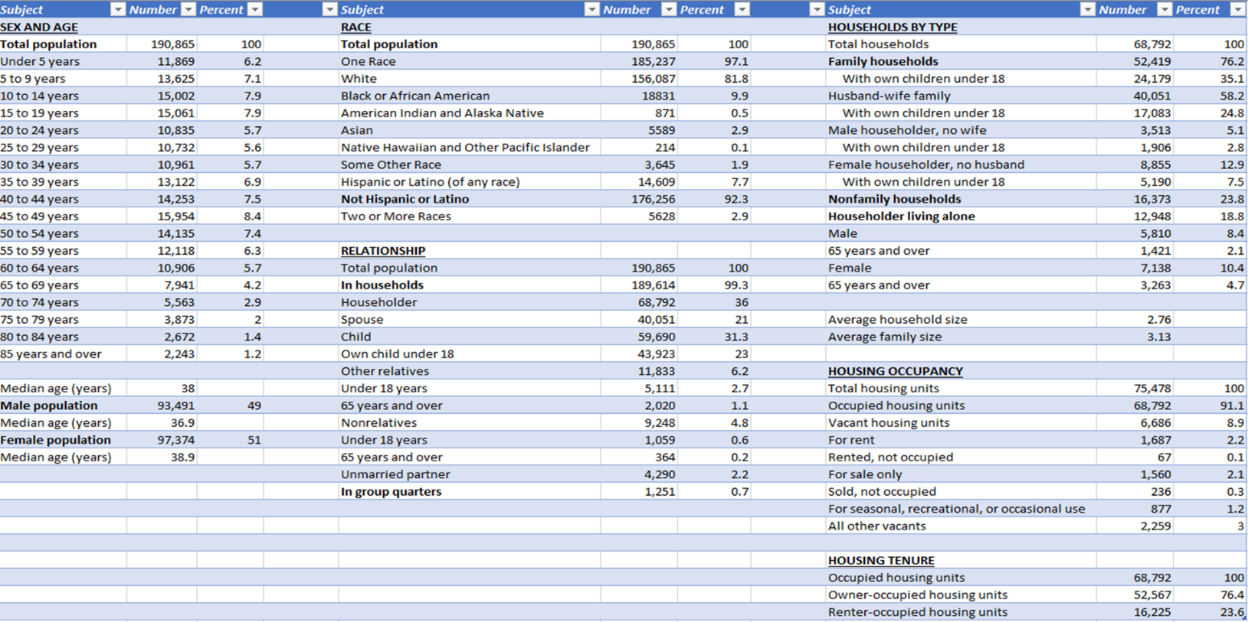

**Research Literature**

Logan and Molotch (2007) discussed the commodification of place, in which place contains both social and economic value, viewed through the lens of special use and exchange values in the economic sense of the terms. Social values incorporate meaning and sentiment assigned to place by its residents and utilizers. Special collective interests in certain locations are born, creating residences and neighborhood locations. Residents and place entrepreneurs purchase properties in areas with high use values, leading to exchange value gain as well. An interest in locations develop, compelling those with money and power to join together to propel further growth; Logan and Molotch referred to this as the growth machine. Clay County’s growth machine has a primary interest in developing the expressway and the land around it as it is considered the key to economic growth. Therefore, it is anticipated that within Clay County, most growth will be seen in the areas neighboring the existing or proposed expressway locations. Figure 2 displays the proposed expressway development. The portion in green has been completed as of July 2019. The yellow portion is currently underway, which will run from the Lake Asbury area to the city of Green Cove Springs.

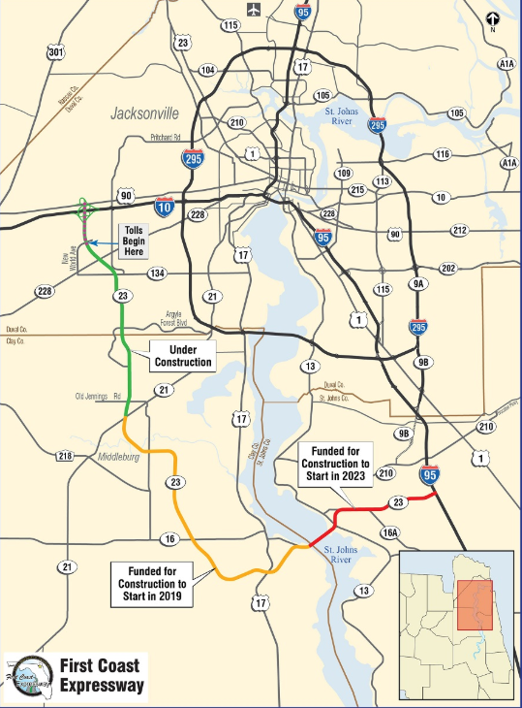

**Figure 2:** Map of the First Coast Expressway (Florida Department of Transportation, 2019).

The commodification of place can also initiate exchange value threats to neighborhoods, such as suburbanization and racial change. Regarding the latter, Logan and Molotch asserted that racial discrimination is still prevalent but declining; Massey, Rothwell, and Domina (2009) and Taylor and Fry (2012) agreed. Therefore, upon viewing county maps, we expected declining but pervasive racial segregation in Clay County. Additionally, the aforementioned researchers agreed that income and class inequality is increasing; income and educational segregation is also expected. Segregation of any form can hinder the growth machine (Watson, Carlino, and Gould Ellen, 2006).

Logan and Molotch also discussed migration, in that people will move where they can maximize their investments and lifestyles unless they are inhibited either internally (investment types, labor), or externally (rules, regulations). Kallick (2015) suggested that immigration drives economic growth and revitalization through small business ownership. Therefore, an examination of the immigrant population is warranted in Clay County. However, due to its rural background and suburban standing, it was expected that Clay County experiences low levels of immigration as other, larger cities with large immigrant populations are nearby.

**Methodology**

The U.S. Census Bureau provided census-tract level data and shapefiles from the 2017 American Community Survey that was cleaned using Excel and Alteryx Designer and subsequently entered into Tableau for analysis. The data contained many important variables, such as race, median household income, poverty, unemployment, economic inequality, and the number of foreign-born residents for each census tract and was joined to the shapefile to produce multiple sheets. Dashboards constructed from multiple sheets are presented for consideration (Figures 3-8).

**Findings**

Race

Figure 3 suggested that most of Clay County’s population lives in the northeastern part of the county, with only a small number living down in the Keystone Heights area in the southwestern area of the county or west of the tract just west of SR 23. Though racial segregation does appear to be present to a degree, the separation of races alone is not extreme. However, suburbanization and growth around the expressway is evident.

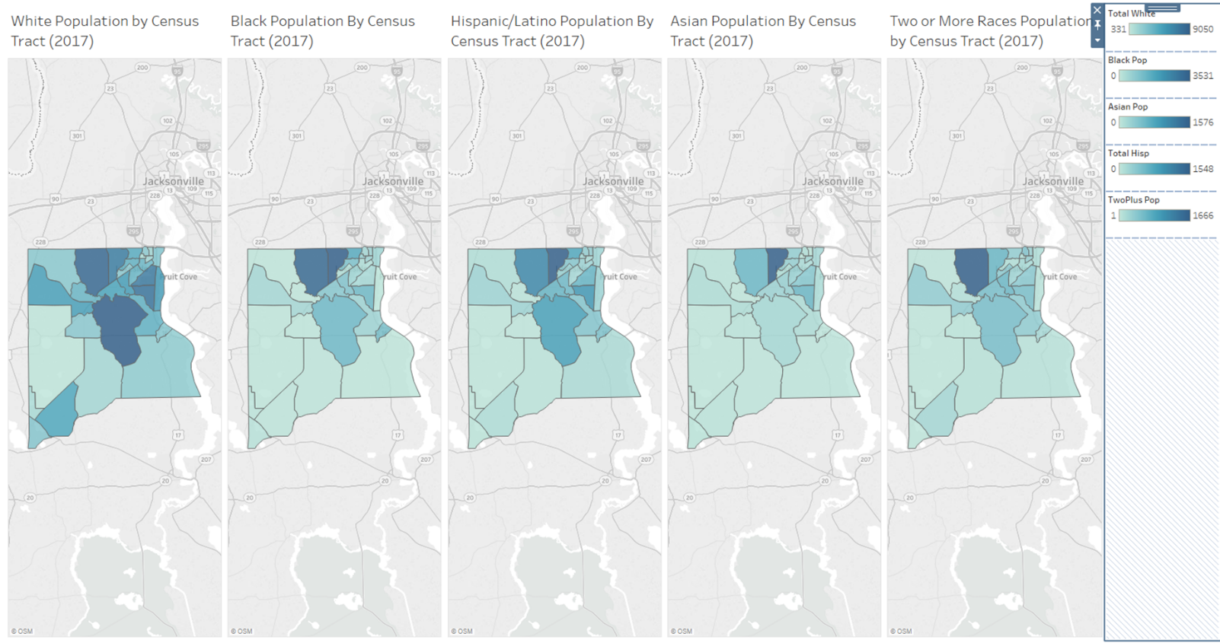

**Figure 3:** Race

Race and Income

Figure 4 displayed race by median household income. The top left-most map represented all households regardless of race and was used as a base for comparison. As the county is predominantly White, the map of White households matches the base map most closely as expected. However, there are interesting patterns that emerge. If one focuses on the dark blue, the highest median-income household areas, the northern Fleming Island tract by Doctors Lake contains upper-income households of any race except Hispanics and Latinos. They are instead near the river and residing in the Lake Asbury tract. Upper-income Blacks are also in Lake Asbury; upper-income Whites are not as prevalent there. Asian households are also found in Oakleaf and Orange Park, where those in the “Two or More Races” category are also in a tract neighboring downtown Green Cove Springs as well as the tracts heading southwest towards Keystone Heights. These maps suggest that while racial segregation is not as prevalent, as there is diversity in many tracts, income segregation appears to be prominent. The poorest (darkest orange) individuals regardless of race are found in the most rural portions of the county and near Keystone Heights.

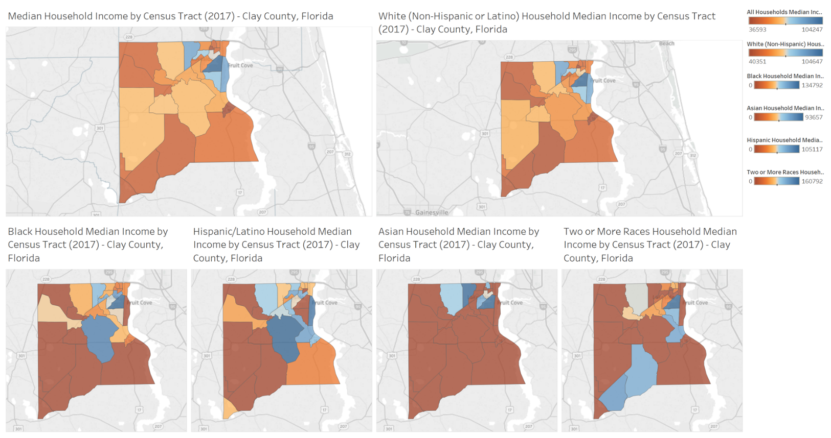

**Figure 4:** Race and Income

Referring back to the top left map of Figure 4, the historic Green Cove Springs area reported the lowest median household income ($36,593); the northern area of Fleming Island nearest Doctors Lake reported the highest ($104,247). Specific intersections in each tract were shown in Figure 5. The intersection of Ferris Street and S. Orange Ave (US-17) in Green Cove Springs is located at the main thoroughfare in town. Using Google Maps street view, the area appeared to be undergoing revitalization and increasing commercialization, confirmed by the city’s website (Green Cove Springs, 2019). Residents are relocating into the myriad of home developments in neighboring tracts. Residential zones and commercial areas were intermixed, however, and the housing appeared smaller and older than in other areas.

In the Fleming Island/Doctor’s Lake tract, an opposite trend surfaced. The commercial zone was completely separate from, but adjacent to, residential areas; the latter make up the majority of the tract. Homes in the area appeared much newer and larger than in Green Cove Springs.

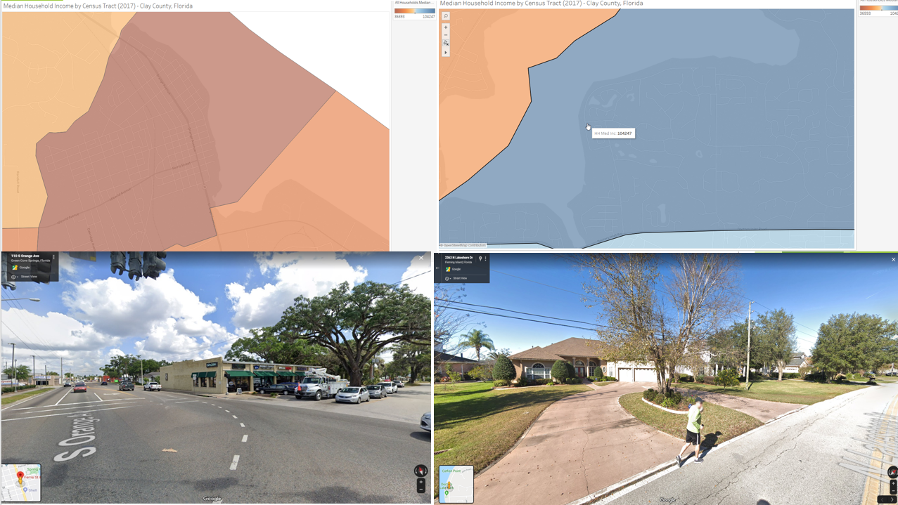

**Figure 5:** Intersections within lower-income and upper-income tract

Poverty and Unemployment

Figure 6 displayed unemployment rates, Gini index, and poverty levels (50% and 500%, respectively) of each census tract. For Green Cove Springs, the tract reported lower unemployment rates due to revitalization and commercialization, while neighboring tracts where residential movement is occurring reported the highest. Most notably, as one moves further from Jacksonville, greater unemployment and inequality is seen. The Lake Asbury tract in particular demonstrates the interaction of some of the poorest citizens with the more well-to-do; this tract in a state of transition and current housing boom and has its own master plan for growth and development (Clay County, n.d.). The expressway running through the tract is expected to create more jobs and opportunities for central tract residents.

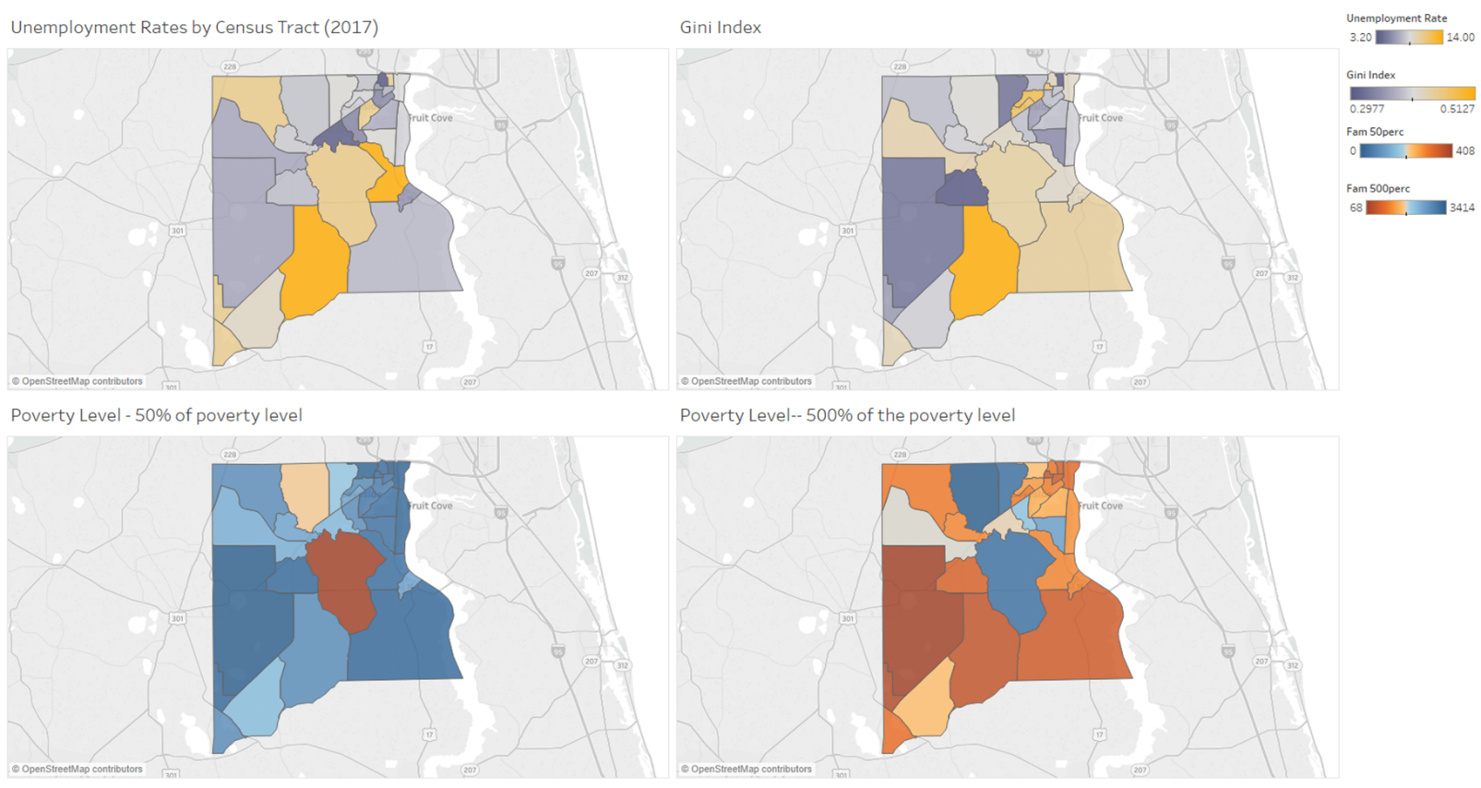

**Figure 6:** Poverty and Unemployment

Education

Figure 7 displays the educational attainment per tract. The data indicated that educational segregation is likely occurring within the county. Overall, those who have a high school education or less tend to live in the more rural portions of the county. Those with bachelor’s degrees or higher live in the northeastern area nearer the city of Jacksonville. There are some of those with graduate and professional degrees residing in the Lake Asbury tract, which could be reflecting the growth spurred by the expressway and/or suburban sprawl.

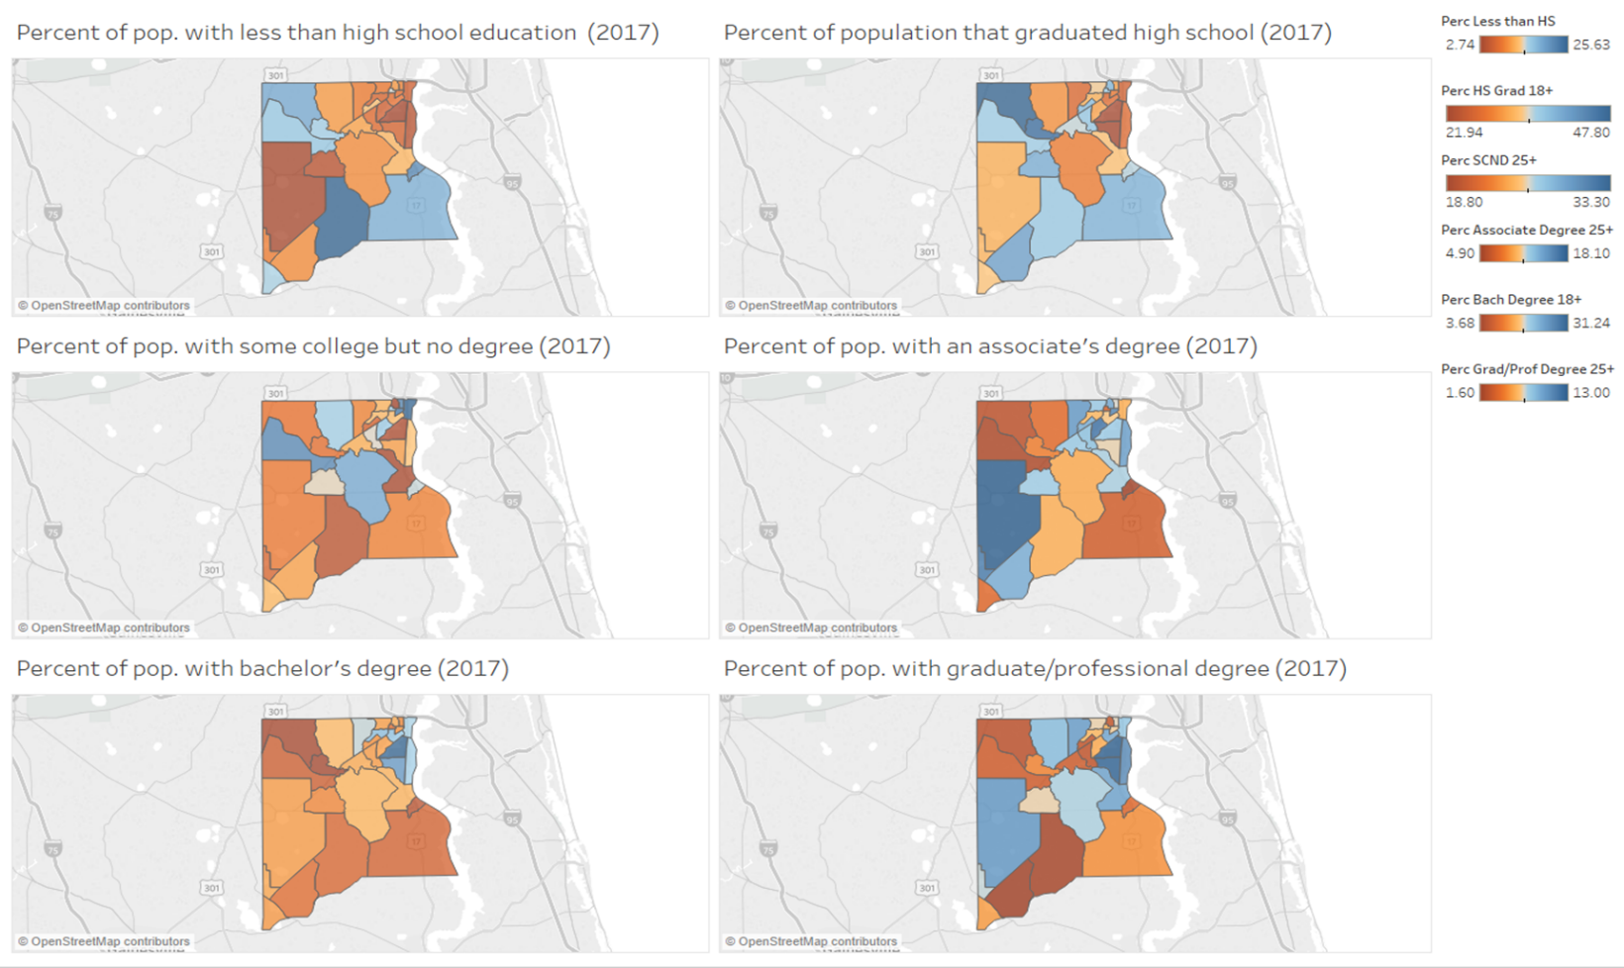

**Figure 7:** Education

Immigration

The total percentage of those reporting themselves as naturalized and non-U.S. citizens was approximately 16%. Other numbers have reported the foreign-born population to be much lower, nearer to 6.89%, likely due to reporting discrepancies (U.S. Census Bureau, 2017). Regardless, recent trends have not shown increasing immigration, with immigrants opting to relocate into Duval or St. John’s County instead where immigrant services and support are greater. This may be due in part to the 2017 reversal of sanctuary status for illegal immigrants and increasing assistance in deportation offered by the Clay County Sheriff’s Office (News4Jax, 2017).

Those who are foreign-born are mostly residing in near Oakleaf Plantation, with a few nearer to Fleming Island and Green Cove Springs. These areas contain large established shopping centers and proximity to the developing expressway. Again, the location is nearer the city of Jacksonville and the services it provides.

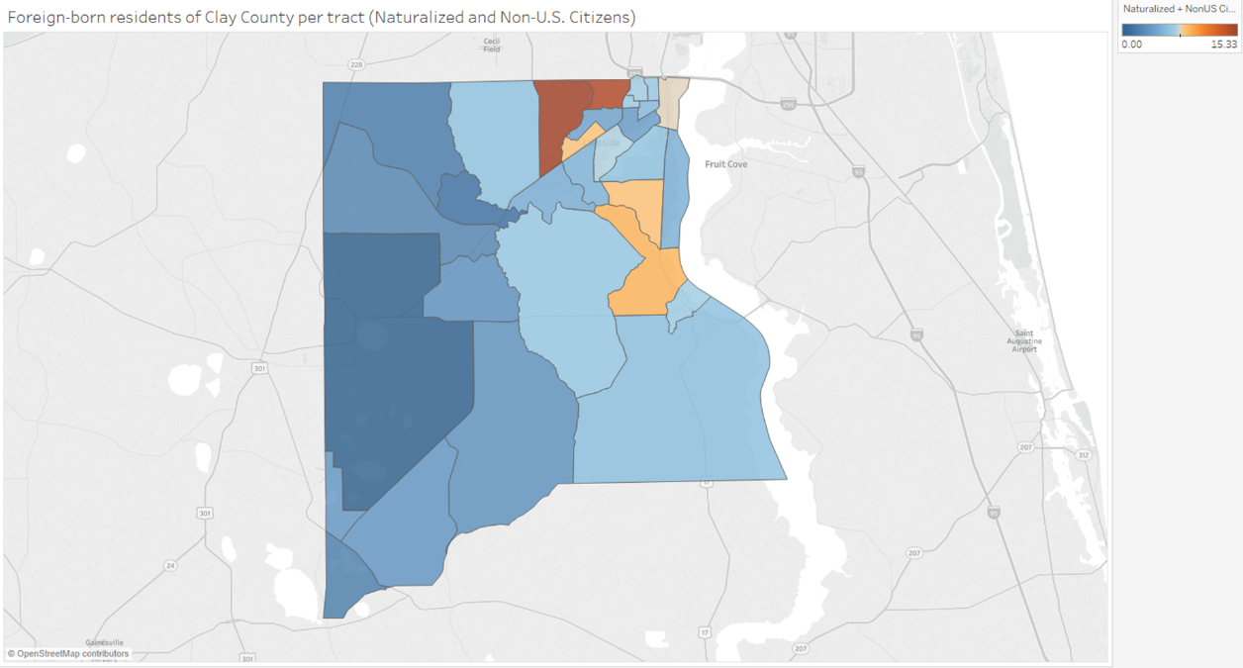

**Figure 8:** Foreign-born residents in Clay County (including naturalized citizens)

**Conclusion**

With relatively low unemployment and poverty, a higher than national median income, and large working age population, Clay County seems to be doing well overall. The growth anticipated by the expressway appears to be coming to fruition. However, the county could benefit from focusing on developing the cities of Keystone Heights and Green Cove Springs. Keystone Heights, in the southwestern corner of the county, is located between Jacksonville and Gainesville. The distance is great enough to either that there is a need for more industry so that more jobs are accessible to residents. The expressway will increase access to and from Green Cove Springs, which is already in the process of revitalization. Building up the cities could reduce reliance on neighboring counties for employment and other social services while improving the economic state of the county.

One way that the cities could improve is if Clay County provided a more welcoming environment to immigrants. The climate has historically been more contentious, but policy and procedural changes could reverse the current trend. As Kallick (2015) indicated, immigrant small businesses could not only bring business to stagnant or declining areas but could also improve diversity, offering a host of social and cultural benefits as well.

Massey et al. had suggested that a way to reduce income inequality is to offer affordable housing near or in upper-income tracts. As housing developments are popping up all over the county and particularly near the expressway’s proposed path, affordable housing units could also be incorporated into development plans as a way to bring more residents out of the rural localities and nearer to employment opportunities. Of course, more housing and more jobs will require improved transportation offerings and better roadways to handle traffic. The expressway will help to some degree; however, restructuring of roadways may need to be included in planning in the near future.

**References**

Chandler, M. (2000). Ten steps in preparing a comprehensive plan. *Planning Commissioners Journal, 39:* 9-11. Retrieved from http://plannersweb.com/wp-content/uploads/2000/07/135.pdf

Clay County. (n.d.). Lake Asbury master plan. Retrieved from https://www.claycountygov.com/Home/ShowDocument?id=856

Clay County, Florida. (2019). *About Clay County.* Retrieved from https://www.claycountygov.com/home/showdocument?id=2870

Florida Department of Transportation. (2019). First Coast Expressway. Retrieved from http://firstcoastexpressway.com/

Green Cove Springs, Florida. (2019). Retrieved from https://www.greencovesprings.com/visioning

Kallick, D.D. (2015, January). Bringing vitality to Main Street: How immigrant small businesses help local economies grow. Fiscal Policy Institute. Retrieved from https://www.as coa.org/sites/default/files/ImmigrantBusinessReport.pdf

Logan, J.R. and Molotch, H.L. (2007). Urban fortunes: The political economy of place. 20th anniversary ed. Los Angeles, CA: University of California Press.

Massey, D.S., Rothwell, J., & Domina, T. (2009, November). The changing basis of segregation in the United States. The Annals of the American Academy of Political and Social Science, 626: 74-90. Retrieved from https://www.jstor.org/stable/40375925

Rousseau, B. (2019, November 20). Clay county is on track to be fast growing county in Florida. *Action News Jax.* Retrieved from https://www.actionnewsjax.com/news/local/clay-county-is-on-track to-be-fast-growing-county-in-florida/912747637/

Sailer, S. (2019, September 27). First coast expressway expected to bring jobs to Clay County. *Jacksonville Daily Record.* Retrieved from https://www.jaxdailyrecord.com/article/first-coast- expressway-expected-to-bring-jobs-to-clay-county

Taylor, P. and Fry, R. (2012, August 1). The rise of residential segregation by income. Pew Research Center. Retrieved from http://assets.pewresearch.org/wp- content/uploads/sites/3/2012/08/Rise-of-Residential-Income-Segregation-2012.2.pdf

U.S. Census Bureau. (2010). *Profile of General Population and Housing Characteristics: 2010, Clay County, Florida.* Retrieved from https://factfinder.census.gov/faces/tableservices/jsf/pages/productview.xhtml?src=CF

U.S. Census Bureau. (2017). Selected attributes from American Community Survey, 2017 5-yr estimates. (Clay County, Florida). American FactFinder. Retrieved from https://factfinder.census.gov/faces/nav/jsf/pages/searchresults.xhtml?refresh=t&keepList=t

Watson, T., Carlino, G., and Gould Ellen, I. (2006). Metropolitan growth, inequality, and neighborhood segregation by income. *Brookings-Wharton Papers on Urban Affairs*: 1-52*.* Retrieved from https://www.jstor.org/stable/25067427.